
understandbutton-


formulatebutton-


formulateSGbutton-

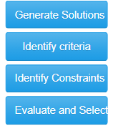
ideatebutton-

evaluatebutton-

consytaintsbutton-

selectbutton-


surveybutton-
Front page
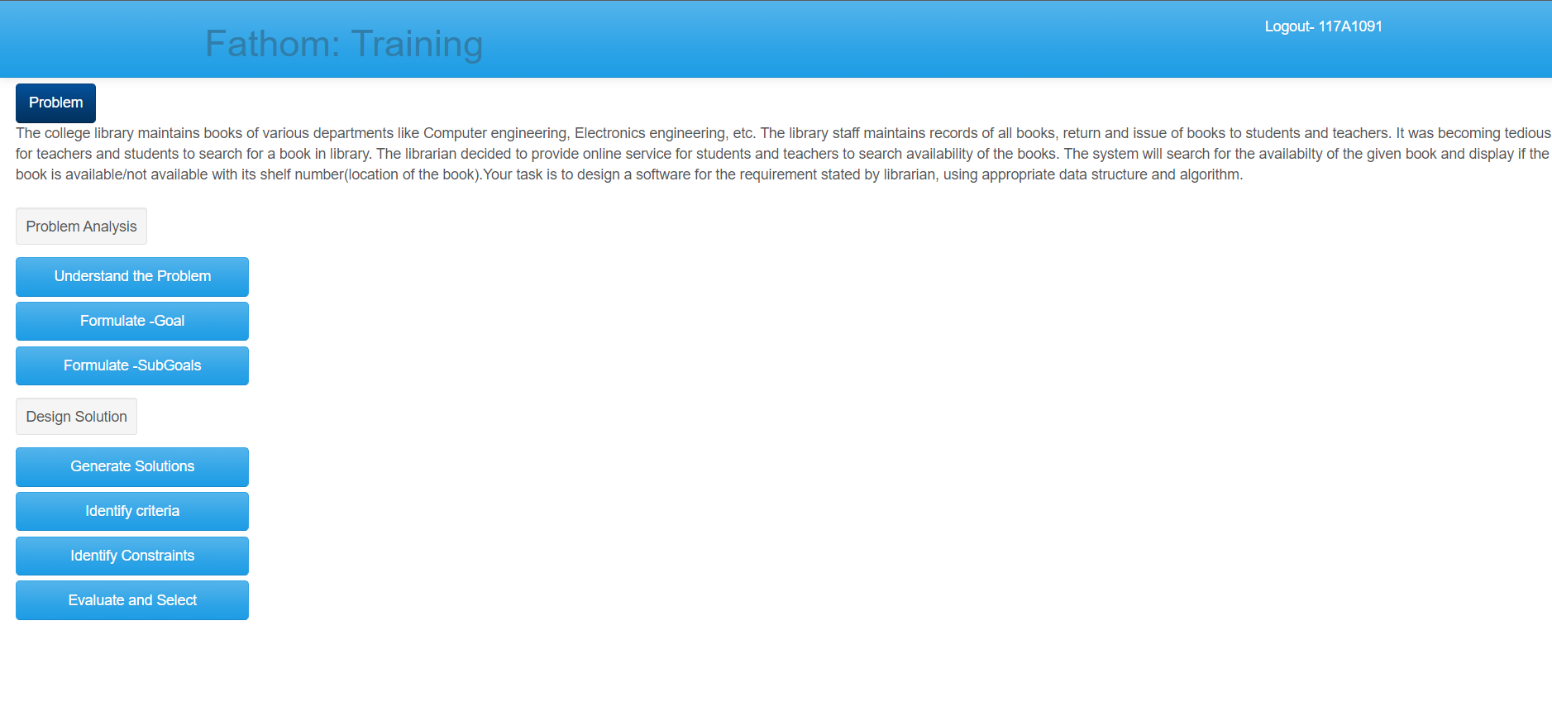
Problem Analysis
1. Understand the problem
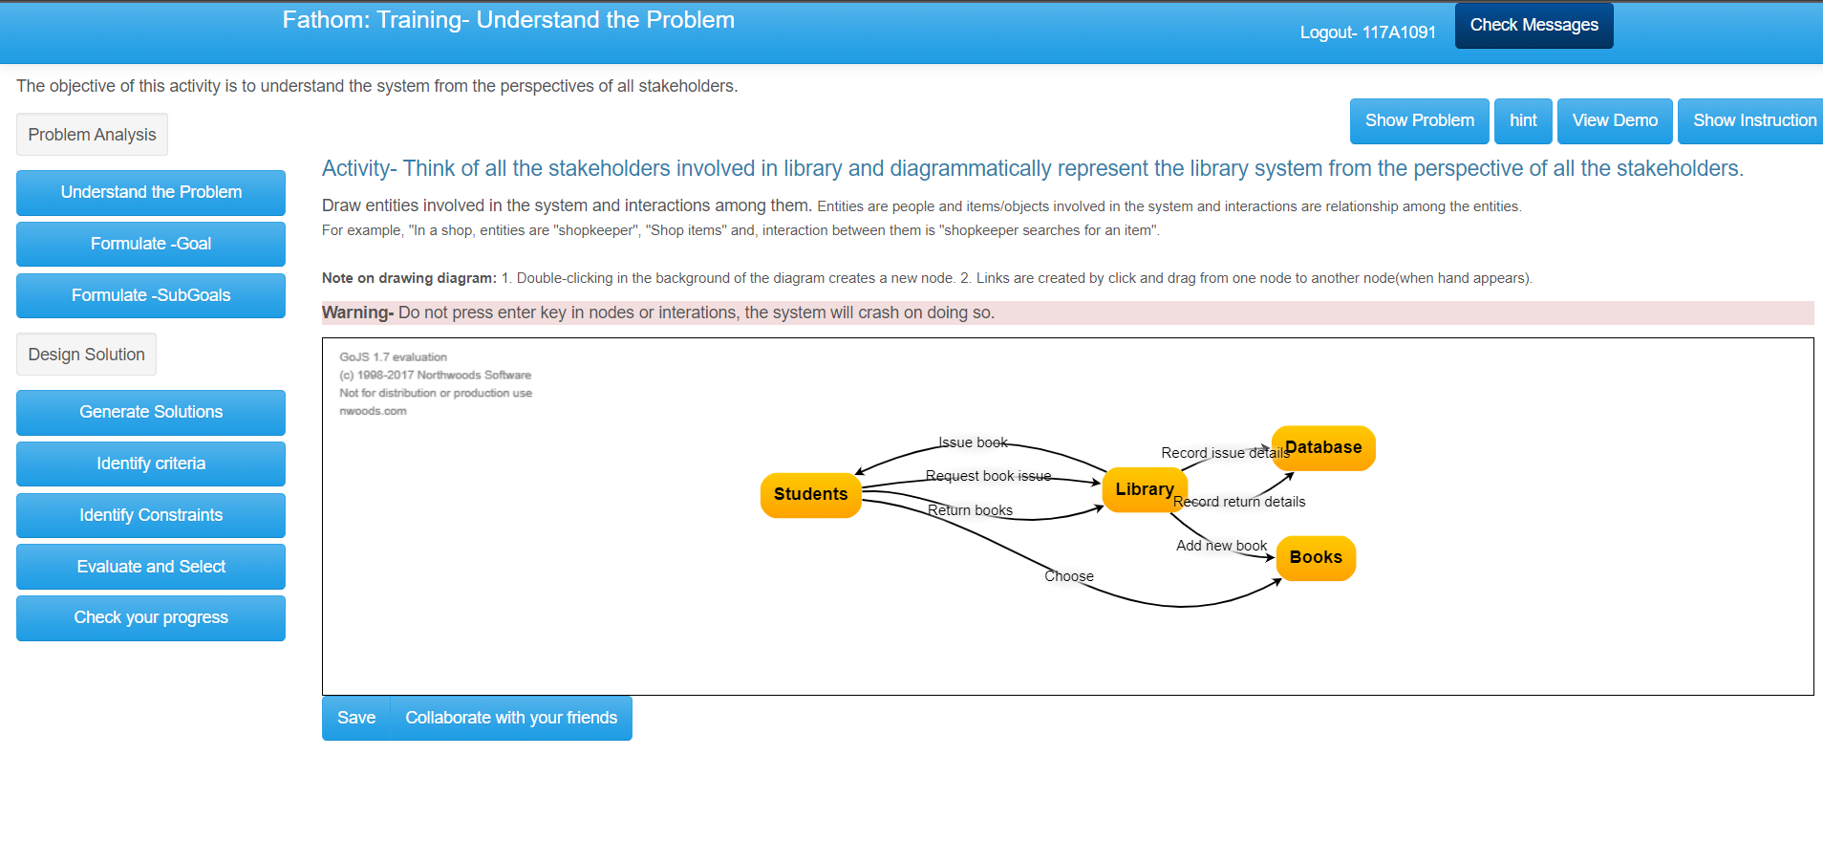
14 possible buttons aside from node insertion part


showproblem-

understandhintbutton-


understandViewDemo-


showinstruction-


next-

savebutton -

2. Formulate Goal

goalhintB- hint button for formulate goal
show problem and show instruction same
SaveButton_goal -

next-
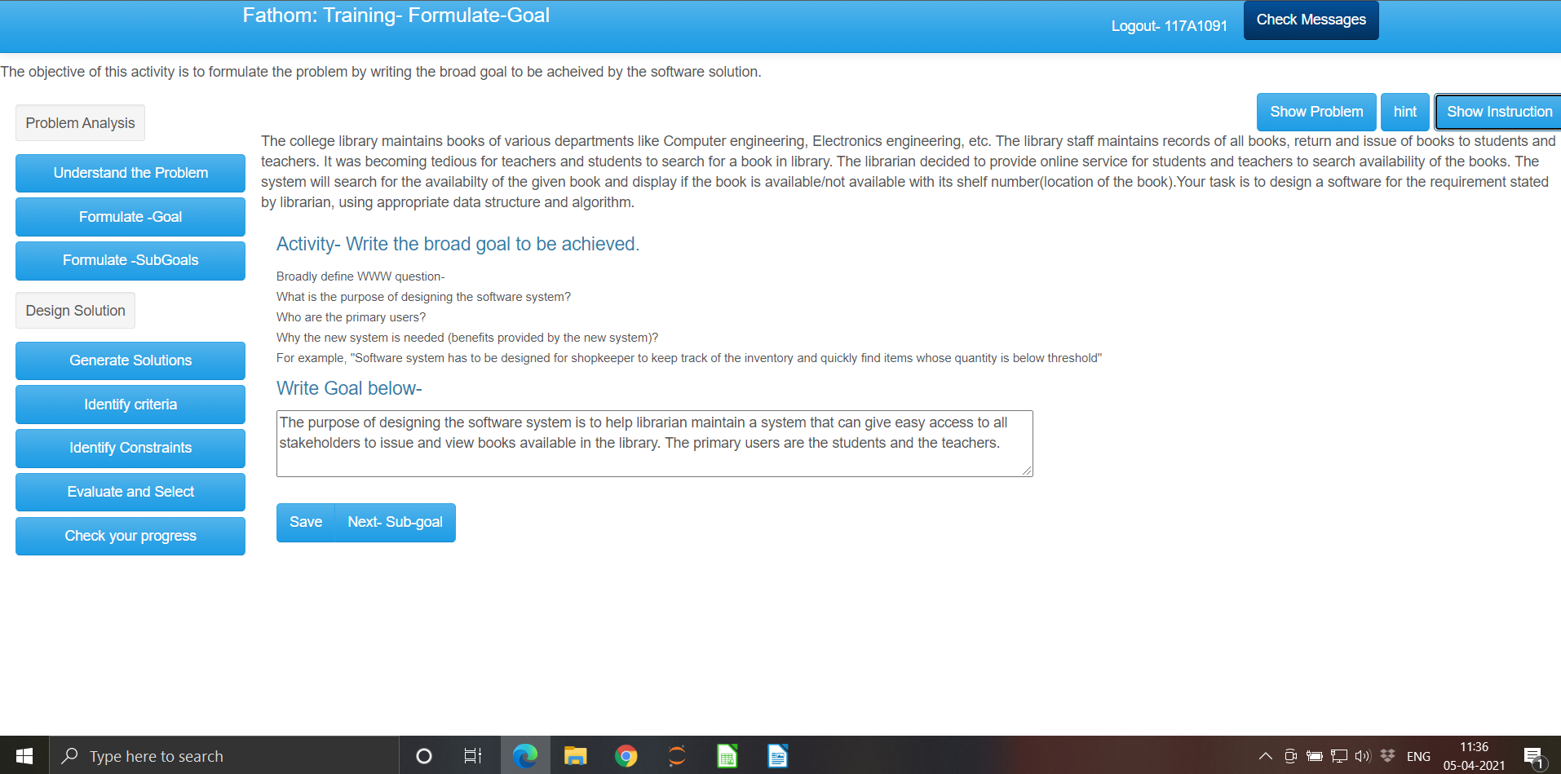
14 possible buttons aside from write goal part

3. Formulate Sub Goals
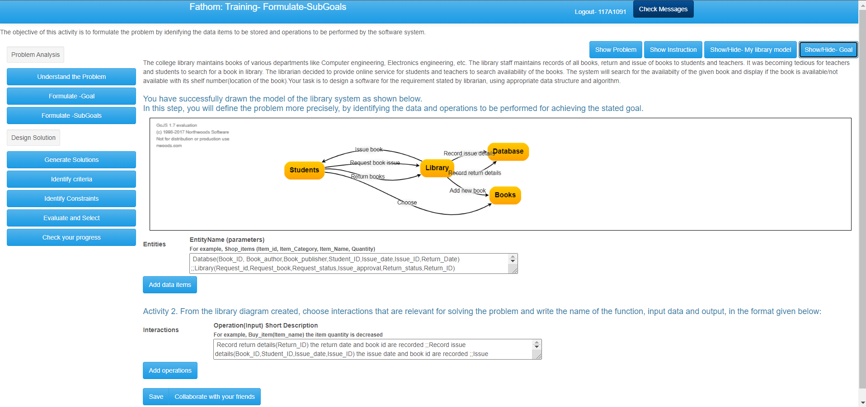
17 possible buttons aside from entity name and operation text box

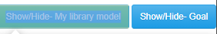

show model show goal

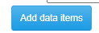
add_dataItem -


add_operation-

SaveButton_subgoal- Save butotn

next – collaborate with friends button

GENERATE SOLUTION PART:

1. Design Solution

showDSMap-


DSA_domainKnow-


SingleMultipleSolutions-


next-

a.
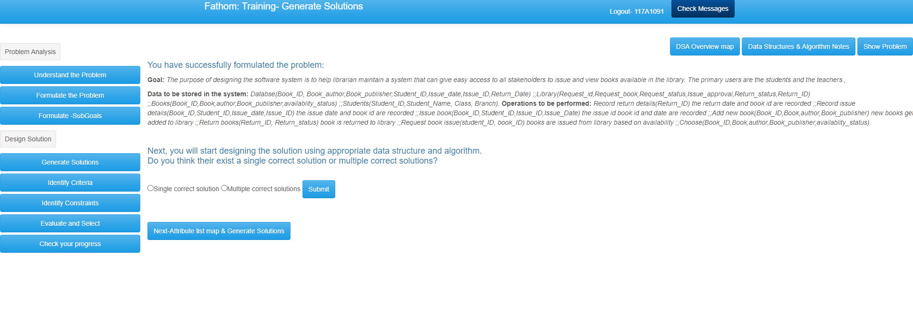
next-
b.
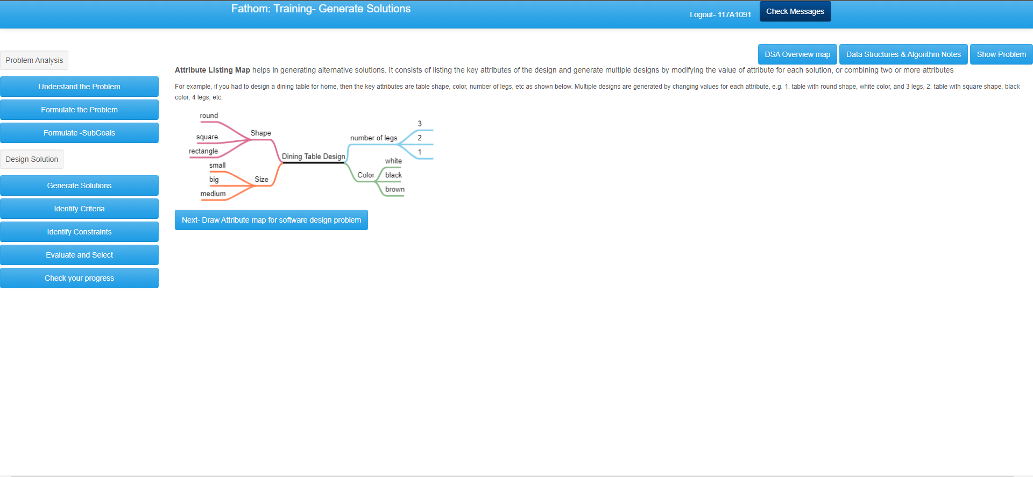

attributemapViewDemo- rest are same



next_mindmap and save-
c.
4 likely butotns in each sub page( a,b c)
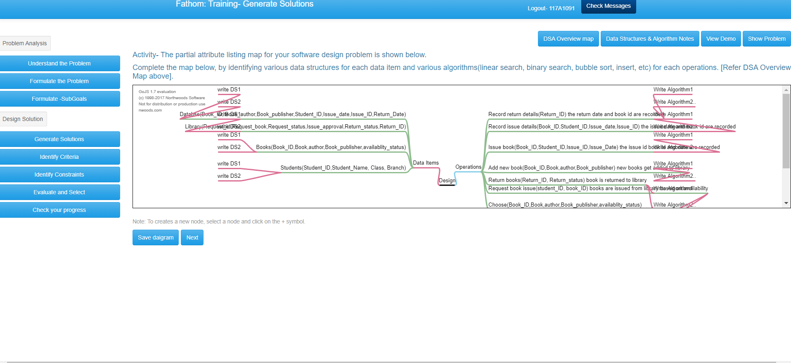
d.
showDiaButton and hint_solution -

rest same

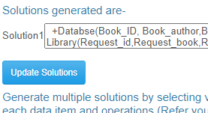
save_gensol-


add_solution and SaveButton_solution -

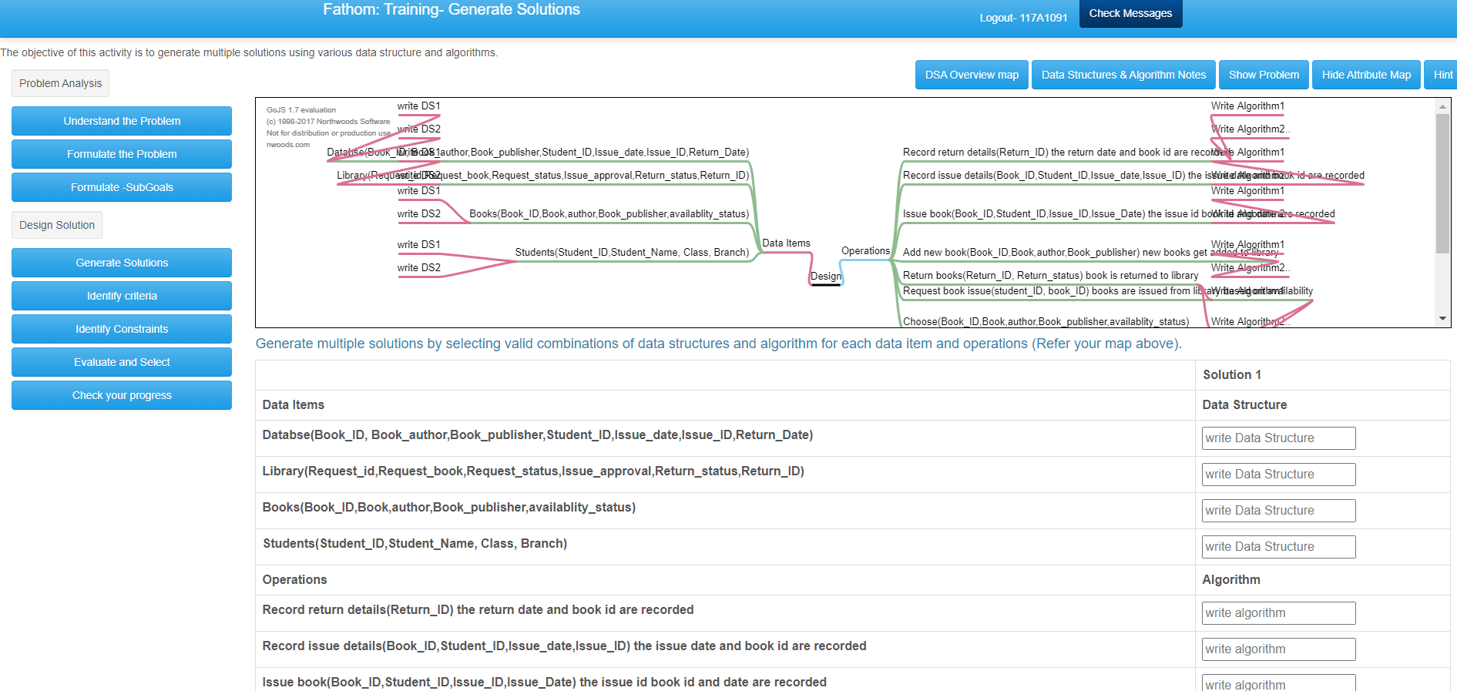
16 buttons
2. Identify Criteria


DSA_domainKnow-


proconbutton-


criteriahintB-

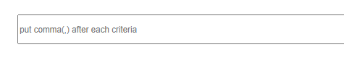
criteria-


SaveButton_criteria and next-

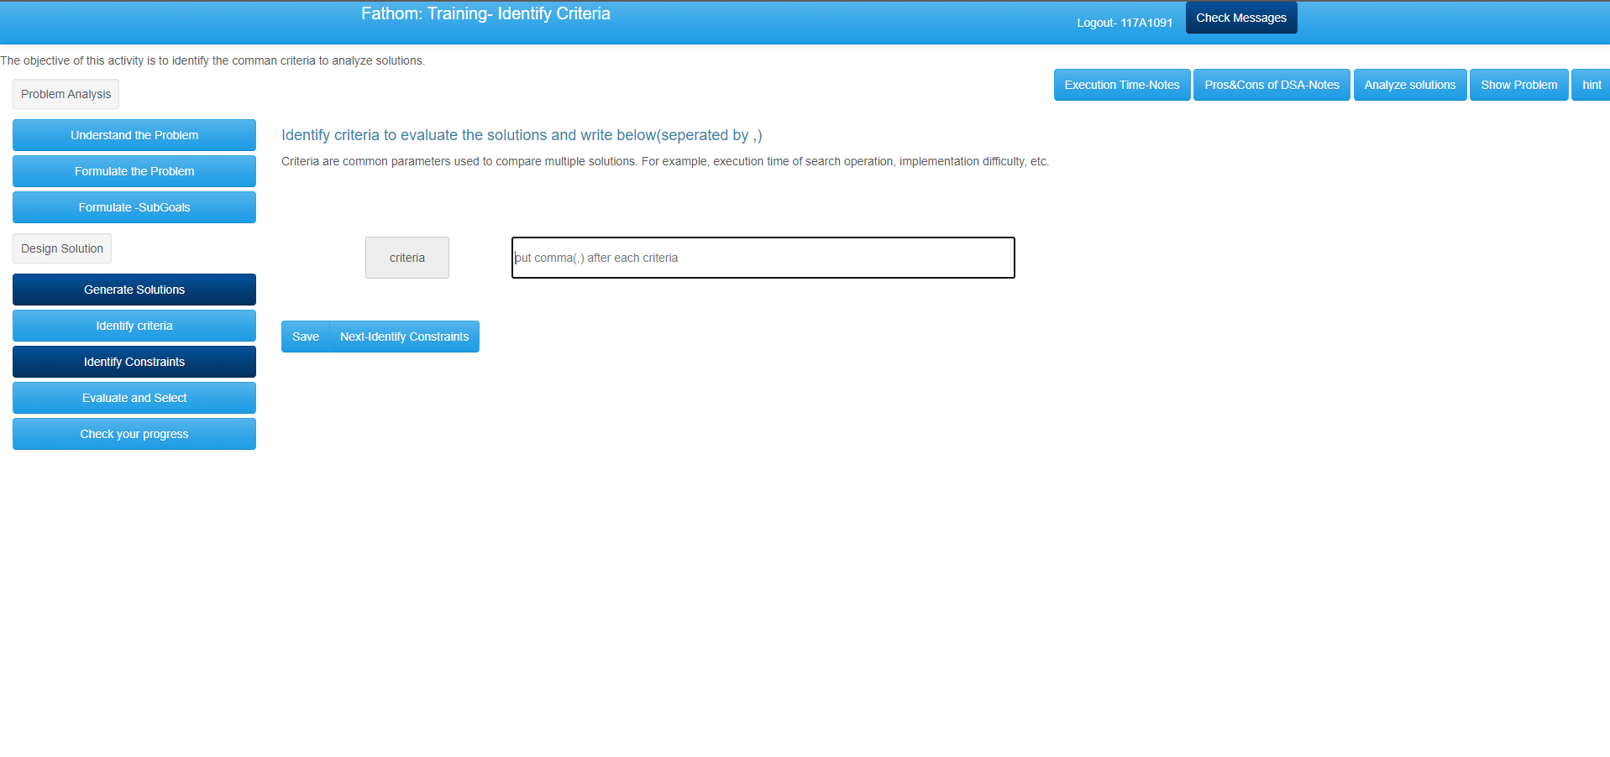
7 usable buttons
3. Identify Constraints
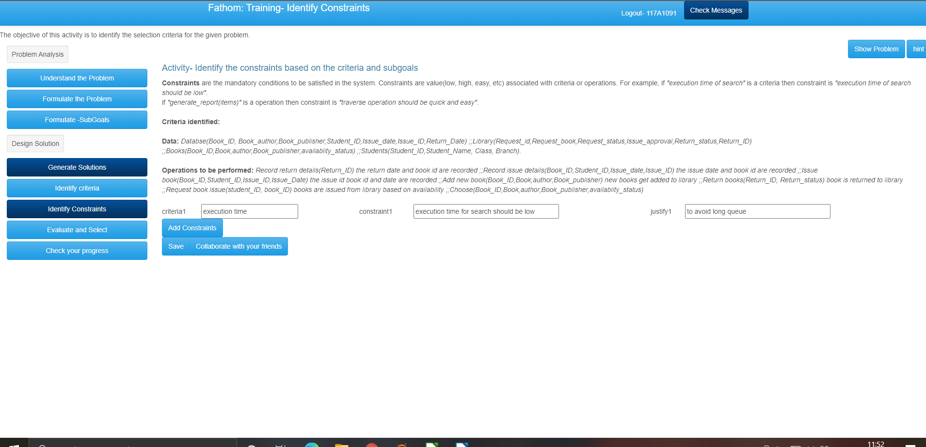

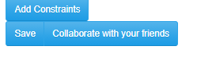
add_entity-
savebutton_constraint-
collaborate- next
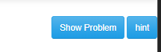
constraintshintB-

4.Evaluate and Select
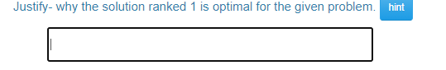

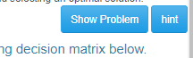
that textbox – Sjustify above pic hint- Justifyhintbutton
dhintButton-
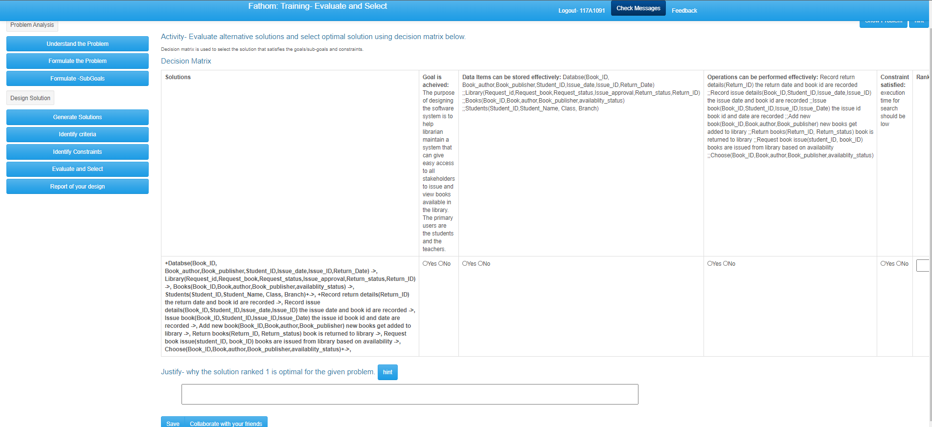
only 4 usable buttons
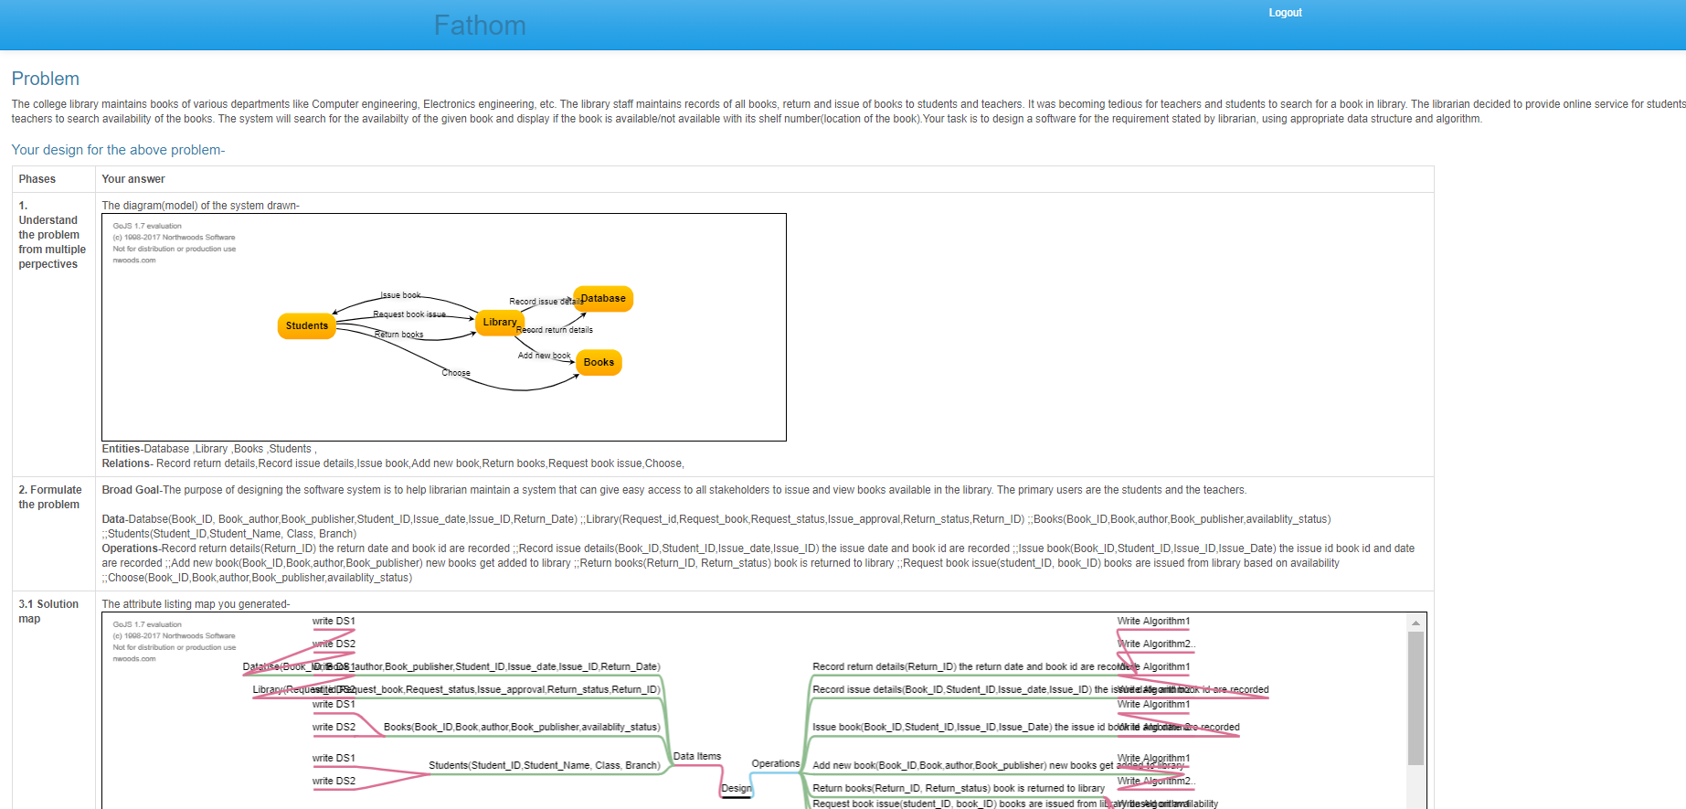

Problem analysis
Design solution
Resources
PA PA R

Section | Buttons | Resources(RA)
Understand Problem(UP) | 1. understandbutton, next,savebutton | understandViewDemo,understandhintbutton,showinstruction,showproblem
Formulate Goal(FG) | 1. formulatebutton,SaveButton_goal,next,formulateSGbutton,add_dataItem,add_operation, SaveButton_subgoal,next | GoalhintB,showinstruction,showproblem,
  show model, show goal, showinstruction,showproblem
Generate Solutions(GS) | 1. ideatebutton, SingleMultipleSolutions, next, next_mindmap, save | 1. showDSMap, DSA_domainKnow, attributemapViewDemo, showinstruction,showproblem
Cretiria(CR) | 1. evaluatebutton, SaveButton_criteria, criteria, next,  consytaintsbutton, add_entity, savebutton_constraint, next | 1. DSA_domainKnow, proconbutton, criteriahintB, showproblem  constraintshintB, showproblem
Evaluate(EV) | 1. selectbutton, Sjustify, SaveButton_Dmatrix, next | 1. Justifyhintbutton, dhintButton, showproblem

RADO- Access Resources and do the task( RA – UP – SAVE)--- > RADO

REDO – Check feedback and then redo task (UP – SAVE – UP) – > REDO

checked Feedback before Save again – Redo

checked Resources before save- Reasource access Ra- RADO

Collab friends before save- CS

FSG', 'FSG', 'SAve', 'GS', 'R', 'R', 'GS', 'GS', 'CR', 'R', 'CR', 'R', 'CN', 'CN', 'CN', 'EV', 'EV', 'EV', 'EV', 'EV', 'EV', 'SV'
FSG Redo Ra CS

earlier op:
['UP', 'FG', 'UP', 'FG', 'UP', 'UP', 'FG', 'UP', 'FG', 'FG', 'FSG', 'FG', 'FSG', 'FSG', 'FSG', 'FSG', 'FSG', 'FSG', 'FSG', 'FSG', 'FSG', 'FSG', 'FSG', 'FSG', 'FSG', 'FSG', 'FSG', 'FSG', 'FSG', 'FSG', 'FSG', 'GS', 'RA', 'GS', 'FSG', 'CR', 'CN', 'EV', 'SV', 'SV', 'EV', 'UP', 'GS', 'FSG', 'UP', 'FSG', 'FSG', 'FSG', 'FSG', 'FSG', 'FSG', 'FSG', 'FSG', 'FSG', 'FSG', 'FSG', 'GS', 'RA', 'RA', 'GS', 'GS', 'CR', 'RA', 'CR', 'RA', 'CN', 'CN', 'CN', 'EV', 'EV', 'EV', 'EV', 'EV', 'EV',

